Name of view: Layered Module View

Primary Presentation:

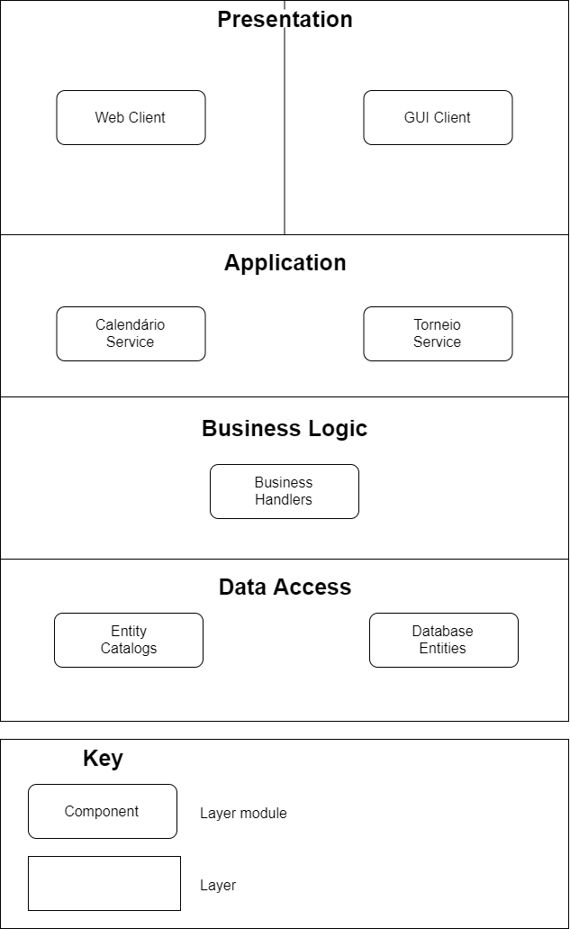

Element Catalog:

* The presentation layer will be composed of 2 clients, a web client and a desktop GUI client. Each will accommodate 2 of the 4 total use cases to be implemented in our system. Both clients will have access to the business layer from which all the data will be retrieved and sent to.
* The application layer will expose the interfaces of 2 main services from which the main methods will be called from. These services will have access to the business logic layer which will take care of all the logical operations given the input from the services with handler classes.
* Each handler class will have access to a set of database entity catalogs from which all data enquiries will be done, whether it be adding to the database or retrieving information.
* To access the WildFly database, the entity catalogs will use JPQL Queries which are defined within the database entity classes. The entities themselves will define the tables in the remote database, i.e. the columns and their respective values.